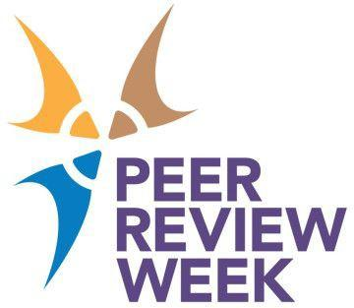

**Write a Blog**

# Everything you need to know about writing a Blog for Peer Review Week

During Peer Review Week (PRW), we encourage you or your organization to blog around the theme of PRW2023. Through this blogging, you can share your viewpoints on peer review, outline tips for others on peer review, and increase the discussion around this critical part of the scholarly community.

Be sure to share your blogs with your network, as well as post them on social media to expand the viewership of your writing. Use the PRW hashtags so we can help promote you too.

# Step 1: Choosing a Topic

The theme of Peer Review Week 2023 is ‘**Peer Review and the Future of Publishing**’ and your event should link with this in some way.

# Step 2: Chose the Format and Write

### What is the objective of your post?

Are you sharing information? Sparking discussion and comments? Promoting peer review activities or initiatives your organization is involved in? This objective will help guide you in the format you use; examples could include:

* Long-form article
* Interview, profile, or Q&A
* Reading list of (and comments on) resources, information, interesting tweets – anything!
* How-to guide, tutorial, or checklist
* Anecdotes or case studies – your own or relevant other individuals
* Quiz, survey, or poll
* Event summaries

### How to Start Planning Your Blog Post

Before starting to write your blog, we recommend that you outline your ideas. Based on the format that you chose above, write down your main ideas and think through your title. As you know, one of the best ways to get individuals to read your article is to pick a catchy headline. Find below resources to assist you in writing headlines, outlines, and how to write your article:

* **Headlines:** [NPR Training: How to write great lines that will keep readers engaged](https://training.npr.org/2015/10/25/the-checklist-for-writing-good-headlines/)
* **Cite and Collect Your Sources:** If you are interested in including research into your article, be sure to research the topic that you want to cover and include your sources in your article and the article outline. When utilizing research or third-party content in your article it is important to cite them correctly. Linking them to your article will increase the discoverability of your article.
* **Outlining Your Blog:** [Forbes: A 10-Point Checklist For Writing A Killer Blog Post](https://www.forbes.com/sites/johnrampton/2017/11/08/a-10-point-checklist-for-writing-a-killer-blog-post/#313da4174897)

**Top tip!** Interested in getting more views on your blog post? Integrate keywords to have it come up on search engines. Learn more about keywords [here](https://ads.google.com/home/tools/keyword-planner/).

* **Write Your Blog Article:** Once you have these items put together, you are ready to write. You may have a few drafts of the article and, once completed, be sure to proofread the article or ask a peer to review it.

# Step 3: Promote the Post

Use all channels available to you, including posting links to your organization’s website, cross-linking with other blogs and sites, and sharing links with colleagues and your wider network.

### Social Media

When sharing your event on social media, please use these hashtags and handles, through which you can expect to receive additional traffic during PRW.

Use the hashtags **#PeerReviewWeek** and **#FutureofPublishing**.

# Reporting to the Peer Review Week Team

Share a link to your post with the [Peer Review Week Team](https://docs.google.com/forms/d/e/1FAIpQLScfVOceQ7zcJtyYLWXPlrIMnGT2t2B4YmxLz_f-7JtA75ca7w/viewform?ts=6481eb12) to benefit from promotion on our channels too.

Don’t forget to register your event with us so we can promote let us know so we can help you promote it.

[**Register your event/activity now!**](https://docs.google.com/forms/d/1d1xC89wkFGcTZmEKoo2TQeMhcVoFqO1HFZltrY23RkI/viewform?ts=6481eb12)